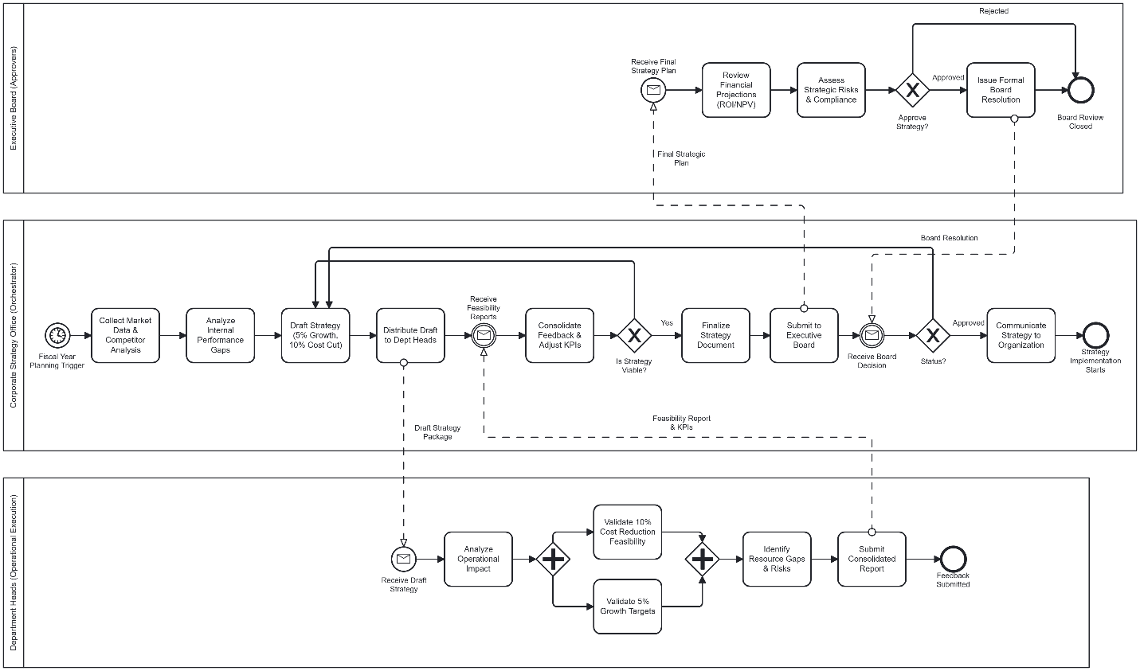
PROCESS 15: Corporate Strategy Planning & Approval
Process Waste Description:
Corporate strategy planning and approval involves developing, reviewing, revising, and approving organizational strategy through multiple stakeholders including departments, finance, and the executive board. Delays occur due to sequential reviews, repeated feedback cycles, and long board approval timelines, resulting in rework and slow decision-making.
DOWNTIME Waste Categorization:
• Waiting: Strategy team waits for departmental feasibility reports and board approvals.
• Excess processing: Multiple revisions of KPIs and strategy documents.
• Motion waste: Strategy documents move back and forth across departments.
Reason for Categorization:
The process contains frequent waiting periods, repeated reviews, and unnecessary movement of documents that do not add direct value and increase overall lead time.
Waste Reduction and Lean Method:
• Conduct parallel feasibility reviews instead of sequential feedback.
• Standardize strategy and KPI templates.
• Lean Tool: Standard Work and Kaizen

PROCESS 16: Annual Budget Planning & Approval
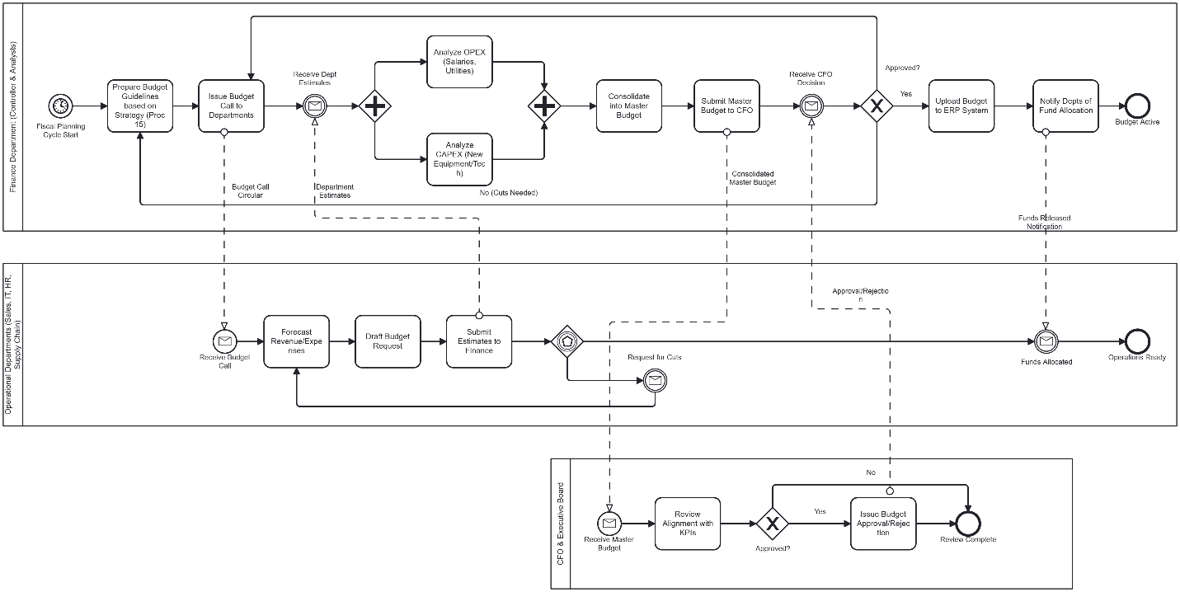
Process Waste Description:
Annual budget planning includes issuing budget guidelines, departmental forecasting, consolidation of OPEX and CAPEX, and final approval by the CFO and Board. The process suffers from repeated forecasting, approval delays, and rework after budget cuts.
DOWNTIME Waste Categorization:
• Waiting: Departments and finance wait for approvals from CFO and Board.
• Excess processing: Multiple re-forecasting cycles after budget revisions.
• Defects: Incorrect or incomplete budget submissions.
Reason for Categorization:
The process frequently pauses due to approvals and corrections, leading to non-value-added work and extended budget finalization time.
Waste Reduction and Lean Method:
• Introduce standardized budget templates and approval timelines.
• Reduce repeated forecasting cycles.
• Lean Tool: Standard Work and Poka Yoke

PROCESS 17: Internal Audit & Compliance Review

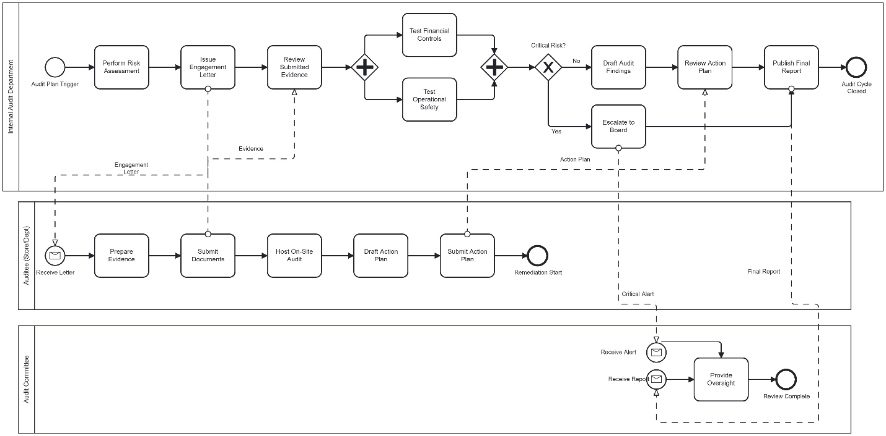
Process Waste Description:
Internal audit and compliance review includes risk assessment, evidence collection, control testing, escalation decisions, and reporting. Delays occur due to incomplete evidence, sequential reviews, and waiting for escalation and final approvals.
DOWNTIME Waste Categorization:
• Waiting: Audit team waits for evidence submission and board decisions.
• Defects: Incomplete or inconsistent audit evidence.
• Excess processing: Multiple reviews of audit findings and action plans.
Reason for Categorization:
The audit process experiences repeated delays, rework, and approval bottlenecks that extend the audit cycle without adding value.
Waste Reduction and Lean Method:
• Use standardized evidence checklists and timelines.
• Reduce duplicate review layers.
• Lean Tool: Standard Work and Kaizen

PROCESS 18: Regulatory Compliance Management
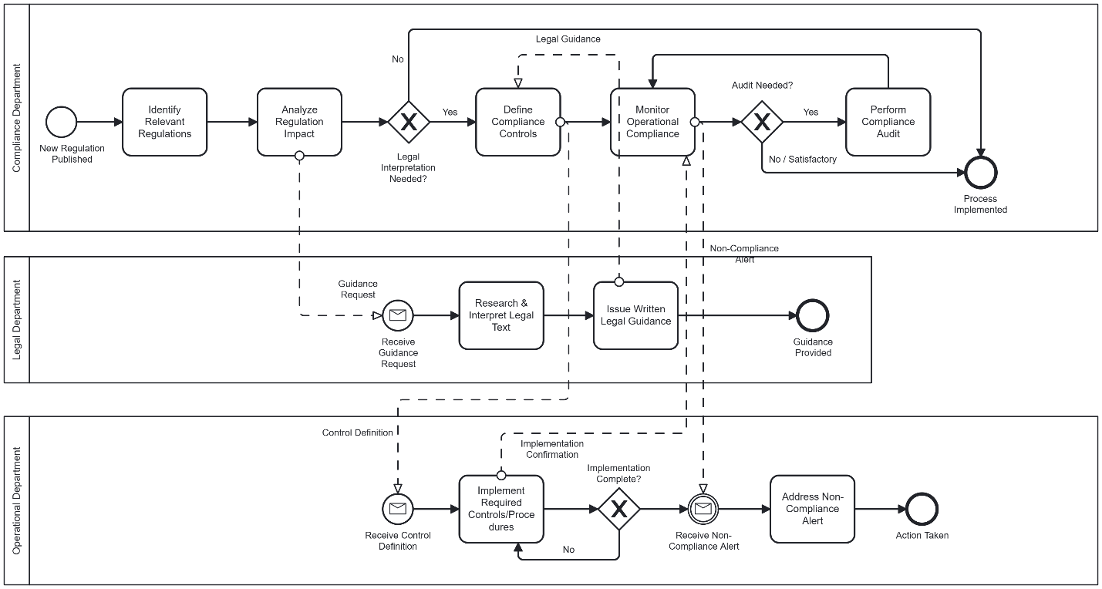
Process Waste Description:
Regulatory compliance management starts with analyzing new regulations and includes legal interpretation, control definition, monitoring, audits, and remediation. Delays are caused by dependency on legal guidance, repeated audits, and manual compliance monitoring.
DOWNTIME Waste Categorization:
• Waiting: Compliance team waits for legal interpretation and audit outcomes.
• Excess processing: Repeated audits and control revisions.
• Defects: Incorrect implementation of compliance controls.
Reason for Categorization:
The process involves frequent waiting for decisions and repeated corrective actions, resulting in slow compliance implementation.
Waste Reduction and Lean Method:
• Standardize legal interpretation and compliance control templates.
• Shift from reactive audits to continuous monitoring.
• Lean Tool: Standard Work and Poka Yoke

PROCESS 19: Supplier Performance Review & Contract Renewal
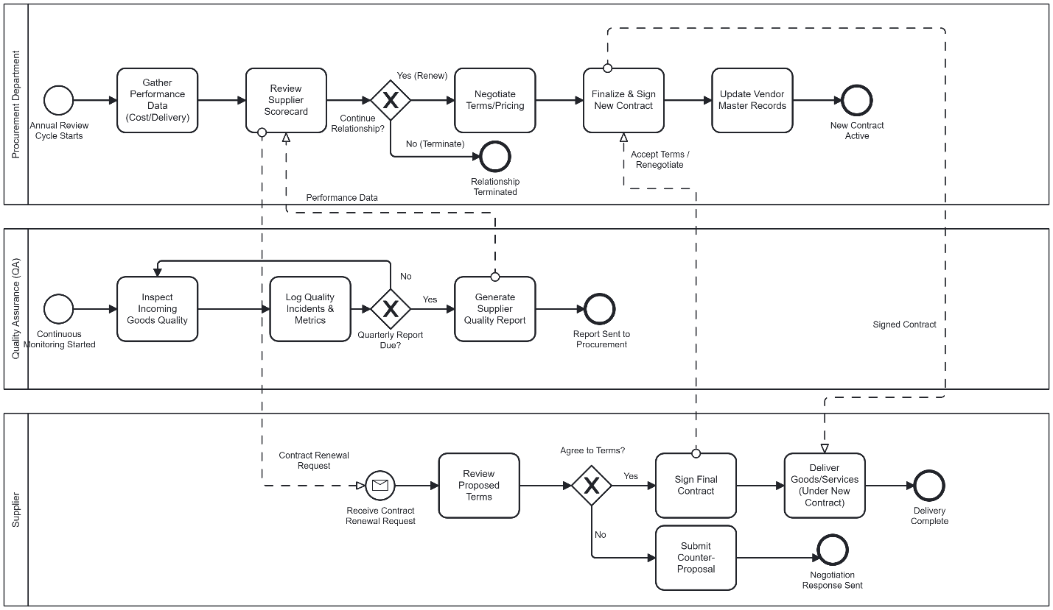
Process Waste Description:
Supplier performance review and contract renewal involves collecting performance data, reviewing supplier scorecards, negotiating terms, and finalizing contracts. Delays occur due to manual data collection, repeated negotiations, and sequential contract approvals.
DOWNTIME Waste Categorization:
• Waiting: Procurement waits for QA reports and approval decisions.
• Excess processing: Repeated reporting and contract revisions.
• Transportation: Information exchanged multiple times between procurement, QA, and suppliers.
Reason for Categorization:
The process experiences waiting during negotiations and approvals, along with repetitive document handling that increases cycle time.
Waste Reduction and Lean Method:
• Use real-time supplier performance dashboards.
• Standardize contract renewal workflows.
• Lean Tool: Standard Work and 5S

